**1. P-N Junction Diode**

**Objective:** To draw the (V-I) characteristics of p-n junction diode and to estimate the dynamic and static resistance.

**Apparatus Required:** Diode trainer kit, Power supply, voltmeter, ammeter and connecting wires etc.

**Theory and Formula Used:** An equation describes the exact current through a diode, given the voltage dropped across the junction, the temperature of the junction, and several physical constants. It is commonly known as the diode equation:

**ID = Is {exp. (eVD/kBT) -1},**

where **ID** is diode current in amps and **Is**is total saturation current in amps.

VD = Voltage applied across diode in Volts, It is positive for forward bias and negative for reverse bias.

kB = Boltzmann's constant (1.38 х10-33)

T = Junction temperature in Kelvin

Suppose a forward bias is applied such that

**exp. (eVD/kBT) >>1, then**

**ID = Is exp(eVD/kBT)**

This shows that in forward bias, current increases exponentially as shown (V-I) graph in figure 3.

When a reverse bias is applied such that

**exp. (-eVD/kBT) << 1, then**

**ID = -Is**

Which shows that in reverse bias current remains constant at **Is** as shown (V-I) graph in figure-3.

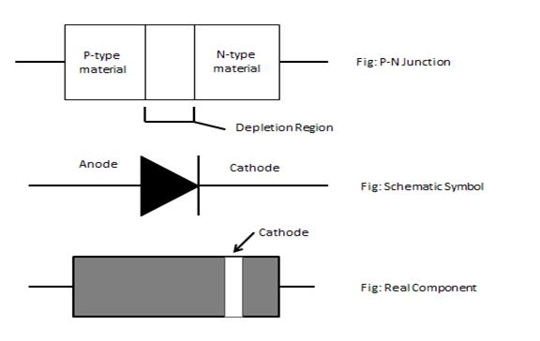

**Figure 1. A P-N junction diode**

When the polarity of the battery is such that electrons are allowed to flow through the diode, the diode is said to be *forward-biased*. Conversely, when the battery is “backward” and the diode blocks the current, the diode is said to be *reverse-biased*. A diode may be thought of as like a switch: “closed” when forward-biased and “open” when reverse-biased.

**Circuit Diagram:** The circuit diagram is as shown below in Figure 3a and b.

1. For forward bias:

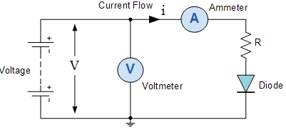

**Figure 3a**

1. Reverse Bias

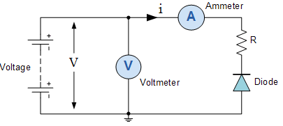

**Figure 3b**

**Procedure:**

**(A) Forward Bias:**

**1.** Before switching on the supply rotate the potentiometer P1 fully in CCW (counter clockwise direction).

**2.** Connect the ammeter between TP4 and TP10 to measure the diode current ID (mA) and set the ammeter to 200 mA range.

**3.** Connect the voltmeter across TP3 and TP11 to measure the diode voltage VD and set the voltmeter to 2 V range.

**4.** Switch on the power supply.

**5.** Vary the potentiometer P1 so as to increase the value of diode voltage VD from 0 to 1V (0.83V) in steps and measure the corresponding values of diode current ID in mA and note down in the Observation Table- 1. From 0.5 V to 0.7 V, take readings in steps of 0.02 V.

**6.** Plot a curve between diode voltage VD and diode current ID as shown in Figure 4 (First quadrant) using suitable scale, with the help of Observation Table- 1. This curve is the required forward characteristics of Si diode.

**7.** Switch off the supply.

1. **Reverse Bias:**

**1.** Before switching on the supply rotate potentiometer P1 fully in CCW (counter clockwise direction).

**2.** Connect the ammeter between TP5 and TP10 to measure the diode current ID (µA) & and set the ammeter to 20µA range.

**3.** Connect the voltmeter across TP3 and TP11 to measure the diode voltage VD and set the voltmeter to 20V range.

**4.** Switch on the power supply.

**5.** Vary the potentiometer P1 so as to increase the value of the diode voltage VD from 0 to 7 V in steps of 0.5 V . Measure the corresponding values of diode current ID in µA and note down in the Observation Table- 2.

**6.** Plot a curve between diode voltage VD and diode current ID as shown in Figure 4 (third quadrant) using suitable scale with the help of Observation Table -2. This curve is the required reverse characteristics of the Ge diode.

**7.** Switch off the supply.

**Observation Tables:**

(A) Forwad Bias (Table-1) (B) Reverse Bias(Table-2)

|  |  |  |  |  |  |  |
| --- | --- | --- | --- | --- | --- | --- |
| **S. no.** | **Diode Voltage (VD)** | **Diode current ID (mA)** |  | **S. no.** | **Diode Voltage (VD)** | **Diode current ID (µA)** |
| 1 |  |  | 1 |  |  |
| 2 |  |  | 2 |  |  |
| 3 |  |  | 3 |  |  |
| 4 |  |  | 4 |  |  |
| 5 |  |  | 5 |  |  |
| 6 |  |  | 6 |  |  |
| 7 |  |  | 7 |  |  |
| 8 |  |  | 8 |  |  |
| 9 |  |  | 9 |  |  |
| 10 |  |  | 10 |  |  |
| 11 |  |  | 11 |  |  |
| 12 |  |  | 12 |  |  |

**Calculations:**

1. Plot a graph between V and I.

2. Find the static and dynamic resistance :

Static Resistance: RD=VD/ID ohms

Dynamic Resistance: rD= ΔVD/ΔID ohms

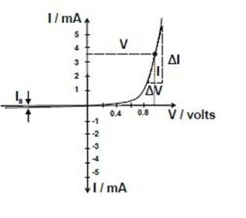

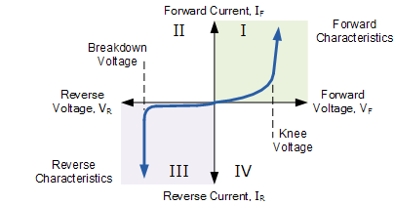

**Figure 4. (V-I) Characteristics of p-n junction diode**

**Result:** The IV characteristics of the diode are shown in the forward and reverse bias. The static and dynamic resistance are Ohms and Ohms.

**Precautions and Sources of Error:**

1. Make sure that all the connections are tight.

2. The voltage should not exceed the specified breakdown voltage in the reverse bias.

3. The voltage should be increased gradually in small steps.